Crash Course #9
The Silk Roads
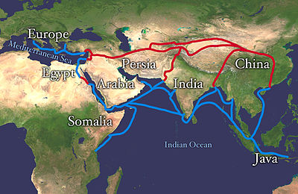

Watch this:

http://www.youtube.com/watch?v=vfe-eNq-Qyg&list=PLBDA2E52FB1EF80C9&index=9

Answer these questions, and use you answers to annotate your Curriculum Framework Guide (CFG).

- How did the Silk Roads reshape lives in Afro-Eurasia?

- Describe the characteristics of the Silk Roads.

- Why were goods that traversed the Silk Roads so expensive?

- Is there a common characteristic that describes the goods that were traded along the Silk Roads?

- What impact did nomadic steppe peoples have on the Silk Roads? How were they well-suited to interact on them?

- “We are the EXCEPTION!” The Mongols are the exception to what general rule?

- Who were the Kushan people and what impact did they have on the Silk Roads?

- What new social class began to emerge during this time and with what impact?

- What are three ways that the Silk Roads impacted the non-wealthy, non-elites? (A three paragraph response.)

Using you responses to this episode of Crash Course, annotate the notes, where appropriate, for Period 2 in your CFG.

