Crash Course #8
Alexander the Great…
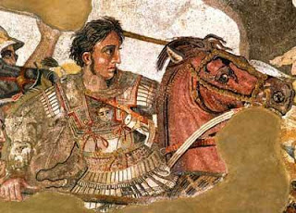
or just pretty good? You decide

Listen to this:

http://www.youtube.com/watch?v=Idh5pWvr8yU

Watch this: http://www.youtube.com/watch?v=0LsrkWDCvxg&list=PLBDA2E52FB1EF80C9&index=8

This episode has very few questions, but does center around popular historiographical theme: The Great Man Theory. We will address this in class. The only thing you need to annotate are those items specifically related to Hellenism and the kingdoms that emerged following Alexander’s death.

Answer these questions, and use you answers to annotate your Curriculum Framework Guide (CFG).

- What definitions of greatness does John Green provide? (need to watch the whole video to get this) How would you define greatness?

- What is the historical significance of Alexander?

- Analyze John Green’s thesis regarding greatness. What do you think makes an individual great? What factors do you think should be taken into account? Is there a “Greatness Formula”? (Like Kim Kardashian Gold? Not)

Using you responses to this episode of Crash Course, annotate the notes, where appropriate, for Periods 1 and 2 in your CFG.

