Crash Course #6
Buddha and Ashoka

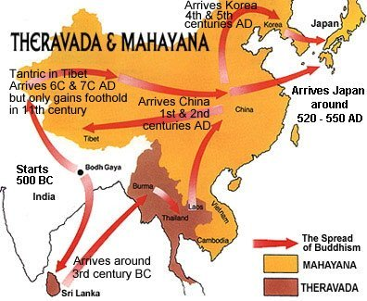

Listen to this:
http://www.youtube.com/watch?v=xKn7-xXyLpY

Watch this:

http://www.youtube.com/watch?v=8Nn5uqE3C9w&list=PLBDA2E52FB1EF80C9&index=6

Answer these questions, and use you answers to annotate your Curriculum Framework Guide (CFG).

- Why is point-of-view (a phrase we use instead of bias) important to keep in mind when studying India?

- What are the Vedas and where did they come from?

- What is the basis for the caste system and what purpose did it serve?

- How does the caste system relate to dharma?

- How did the concepts of samsara, moksha, and karma provide social cohesion in India?

- What are the Four Noble Truths and the Eightfold Path?

- Why did Buddhism have such a strong appeal to certain groups but not others?

- What did Ashoka accomplish? What are the key ideas found on Ashoka’s Pillars?

- How was Hinduism able to adapt to resist the challenge of Buddhism in India?

Using you responses to this episode of Crash Course, annotate the notes, where appropriate, for Period 1 and 2 in your CFG.

