Crash Course #4
Ancient Egypt
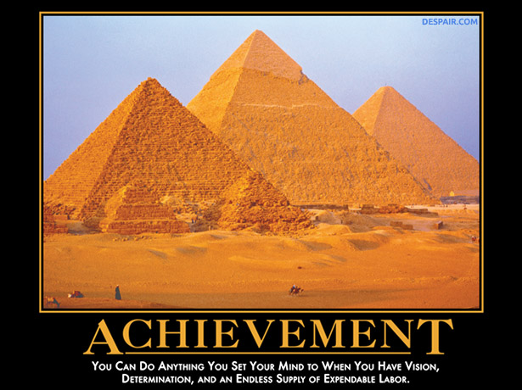

Listen to this:

https://www.youtube.com/watch?v=1JqlAD7dn-E

Watch this:

https://www.youtube.com/watch?v=Z3Wvw6BivVI

Answer these questions, and use you answers to annotate your Curriculum Framework Guide (CFG).

- What point is John Green making about the different “lenses” we use when we study history?

- How did the Nile River shape the worldview of the Egyptians? How did this compare to the Mesopotamian worldview?

- How was Egyptian Civilization different from most other River Valley Civilizations? Why do you think this was?

- What does the construction of the pyramids represent? (not “what was the purpose of the pyramids?”)

- What was the motivation for building the pyramids? (not “what was the purpose of the pyramids?”)

- What changes took place in the transition from the Old Kingdom to the Middle Kingdom?

- Amon-Ra or Top Ramen…you decide…

- What protected Egypt from outside peoples? How were the Egyptians eventually conquered by Semitic peoples of the Middle East?

- What changes took place in the transition from the Middle Kingdom to the New Kingdom?

Using you responses to this episode of Crash Course, annotate the notes, where appropriate, for Period 1 in your CFG.

