Crash Course #3
Mesopotamia
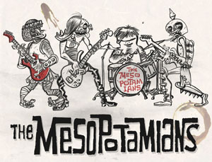

Listen to this: https://www.youtube.com/watch?v=jAMRTGv82Zo

Identify the members of the band with a one sentence bio for each, identifying role, time, and place.

Watch this:

http://www.youtube.com/watch?v=sohXPx_XZ6Y&list=PLBDA2E52FB1EF80C9

Answer these questions, and use you answers to annotate your Curriculum Framework Guide (CFG).

- John Green begins by discussing one of the most obvious consequences of agriculture…what is it and what are the most immediate consequences for those societies?

- Grade 9 Humanities Question- Gilgamesh…Rural vs. Urban: explain what John Green is talking about?

- Historically speaking, why do you think cities tend to win? But did cities always win? Explain.

- Why do you think early cities devoted resources to building monumental architecture, like ziggurats?

- How does Mesopotamia compare with the Indus River Valley (IRV)? Identify both similarities and differences. Think of why a specific similarity and a specific difference might exist. (This is analysis; one of the more challenging skills you will need to develop).

- How might the environment of Mesopotamia influence or shape people’s perceptions of their gods?

- What is the significance of the emergence of palaces? How did kings gain power over priests? How did they keep it?

- CUNIEFORM: What three points does John Green make about the advent of writing?
a)
b)
c)

- How did the environment of Mesopotamia shape the economy of the society?

- What factors led to the downfall of the Mesopotamian city-states and to what effect? (A causes and effects question)

- MONGOLS! The Mongols are the exception to what general rule?

- What was Hammurabi’s most significant contribution?

- Compare new city-states with the old city-states of Mesopotamia. Identify 3 specific similarities and 3 specific differences. State a reason for at least one similarity and one difference.

- Who provided the basis for the development of territorial kingdoms? How? Why does this “base” prove to be unsteady?

- What legacy did the Assyrians leave?

- What are the challenges of empire what is the usual result? Or to put it in math terms:
______________ + ________________ = ______________________

17. How did Assyrian kings attempt to legitimize their rule?

Using you responses to this episode of Crash Course, annotate the notes, where appropriate, for Period 1 in your CFG.

