Crash Course #7
China 2,000 Years
and the Mandate of Heaven

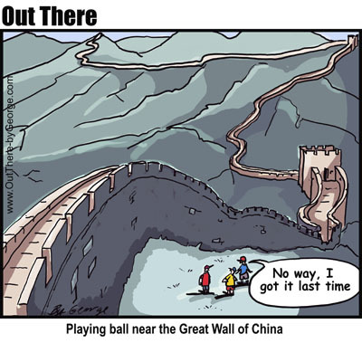

Watch this: http://www.youtube.com/watch?v=ylWORyToTo4&list=PLBDA2E52FB1EF80C9&index=7

There are not as many questions with this episode but the answers do require a longer response.

Answer these questions, and use you answers to annotate your Curriculum Framework Guide (CFG).

- What characteristics made China the first “modern state”?

- Create a timeline of Chinese Dynasties (include interludes) from the mythical Xia dynasty to the creation of the Republic in 1911.

- Explain the Mandate of Heaven and how it works.

- Describe the Confucian belief system. How does it manifest itself in Chinese culture today?

- MONGOL EXCEPTION QUESTION? In what way does John Green claim the Mongols are an exception in this episode? Is this an accurate claim? Why or why not?

Using you responses to this episode of Crash Course, annotate the notes, where appropriate, for Periods 1 and 2 in your CFG.

