Crash Course #5
The Persians and Greeks
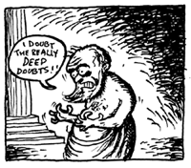

Watch this:

http://www.youtube.com/watch?v=Q-mkVSasZIM&list=PLBDA2E52FB1EF80C9&index=5

Answer these questions, and use you answers to annotate your Curriculum Framework Guide (CFG).

- “We are the EXCEPTION!” The Mongols are the exception to what general rule about empires?

- Explain the concept of historical bias using “the Father of History”, Herodotus, as an example.

- Describe the characteristics of the Persian Empire.

- How did the Persian religion of Zoroastrianism impact the development of labor systems in Persia?

- Describe the Greek City-States.

- What was the cause of the Persian Wars?

- What was the cause of the Peloponnesian War?

- What is “realism” in political terms? What quote did you just hear that succinctly explains that philosophy?

- What arguments can be made that a Persian victory might have been a good thing?

- Flashback Question: How do we know much of what we “know” about the Persians? Make a mental note to hold on to this idea. It has an important underlying concept to which we will continually refer.

Using you responses to this episode of Crash Course, annotate the notes, where appropriate, for Periods 1 and 2 in your CFG.

