Crash Course #2
Indus Valley Civilization
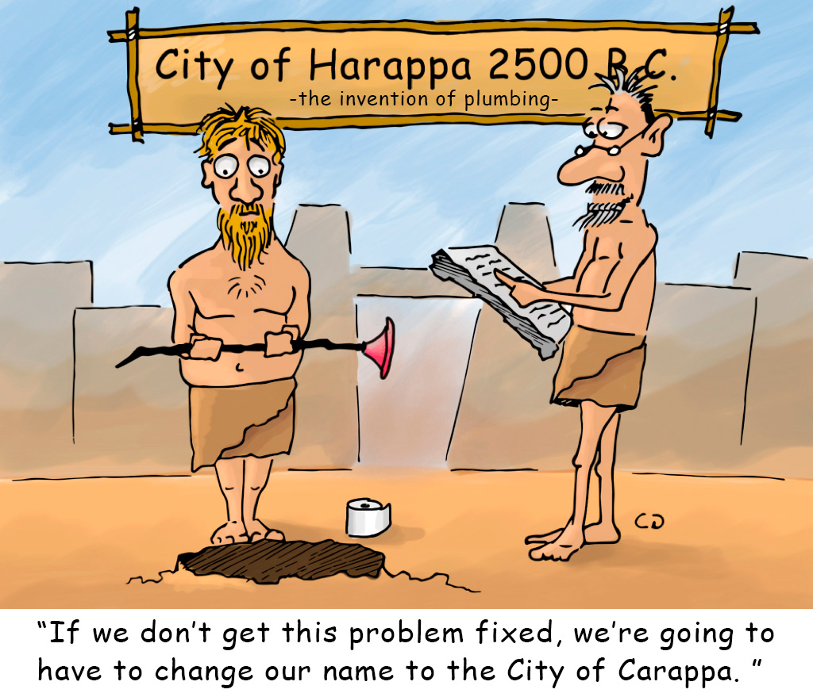

Watch this:

http://www.youtube.com/watch?v=n7ndRwqJYDM&list=PLBDA2E52FB1EF80C9&index=2

Answer these questions, and use you answers to annotate your Curriculum Framework Guide (CFG).

- How is the concept of “civilization” a useful construct? When is it not a useful construct?

- How does John Green define what constitutes a civilization? How does this compare to other definitions of civilization you have learned?

- Where did the earliest civilizations emerge? Why there?

- Why was the Indus Valley a prime location? How did the environment impact the people who lived there?

- How do we know, what we know, about the IVC?

- How did they use technology to interact with the environment to improve their quality of life?

- What evidence exists of long-distance trade and with whom?

- What appears to be unique about the IVC, based on your knowledge of other civilizations?

- What theories do historians have about the fate of the IVC? As historians, what evidence might one look for to support or disprove these three theories?

Using your responses to these questions annotate the appropriate sections of your Key Concepts Guide, Per. 1.

