Crash Course #1
Agricultural Revolution
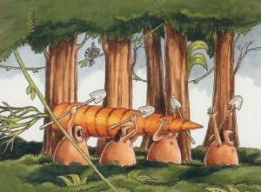
Early vegetarians returning home from the kill

Watch this:

http://www.youtube.com/watch?v=Yocja_N5s1I&list=PLBDA2E52FB1EF80C9&index=1

Answer these questions, and use you answers to annotate your Curriculum Framework Guide (CFG).

- How do we have evidence of Hunter-Gatherers (H-G) and their lifeways? (New word that means “ways of life”, do not use “lifestyle”).

- What do most early civilizations have in common?

- What advantages did H-G have over early agriculturalists?

- Where did agriculture emerge? Which food crops are associated with which areas?

- What are the advantages and disadvantages of agriculture?

- What impact does agriculture have on the environment?

- What other lifeway emerged besides being a H-G or a farmer (agriculturalist)?

- What were the advantages and disadvantages to Pastoralism (being a herder)?

- Welcome to the MONGOLS! We love talking about the Mongols! We are…wait for it… ________________________.

- What advantages do you think that Eurasia had with its zoological set of animals compared to the Americas?

- Evaluate John Green’s thesis that “the greatest evolutionary advantage an animal species can have is being useful to humans.” Agree/disagree, why?

- If H-G had a “better and healthier” lifeway, why did people become agriculturalists?

- What point do you think John Green is making about the use of the word “savage”? How might this also apply to concepts of being “civilized” or “uncivilized”?

- What do historians say are the drawbacks to complex civilizations and agriculture?

- What other impacts do complex civilizations have on the environment?

- What does John Green say about “revolutions”?

- What does DFTBA mean?

Using you responses to this episode of Crash Course, annotate the notes, where appropriate, for Period 1 in your CFG.

