AP World History: Modern – Themes Acronyms

S Social Interactions (SIO) 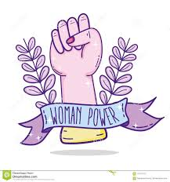
P Political Systems and Ideologies (GOV)
I Interactions with the Environment (ENV) 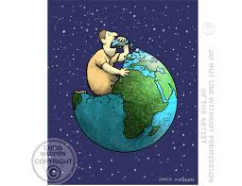
C Culture and Interactions (CDI) 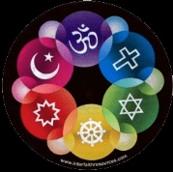
E Economic Systems (ECN)
T Technology & Innovations (TEC)

